UNIVERSITY OF IBADAN
DEPARTMENT OF COMPUTER SCIENCE
B.SC. DEGREE EXAMINATIONS (FIRST SEMESTER, 2022/2023)

CSC 431 (Compiler Construction)
Answer Question 1 and any other Two 2 Hours

Question 1:
- A compiler can broadly be divided into two phases based on the way they compile.
Explain with a simple illustrative diagram. [6 marks]

- Explain the following types of compilers
  - single pass compilers
  - multiple pass compilers
  - Compiler-Compilers
  - Cross Compilers
  - Source-to-source Compiler [2 marks each = 10 marks]

- State any four (4) qualities of a good compiler [4 marks]
- State the tasks that are involved in lexical analysis. [3 marks]
- What are the important tasks performed by the parser? [7 marks]

Question 2:
(a) Discuss the reasons for including Error Handling routines in Compiler design
and construction [6 marks]
(b) The use of an undeclared identifier in a program is an error.
The error could have arisen in several ways. Discuss. [3 marks]
(c) Explain the following levels of error in compiler construction:
Notes, Comments, Warnings, Errors, Fatal errors and Deadly Errors [3 marks]
(d) What are the wish list of a compiler error handler? [3 marks]

Question 3:
(a) The aspect of code generation in compiler construction is actually an arduous task. Why?
[3 marks]
(b) The code generator should take some factors into consideration in order to
generate the target code. Discuss any three of these factors [8 marks]
(c) Explain the alternatives available to a compiler designer to generate outputs after the quadruples, triples or the postfix forms of the source language have been generated [4 marks]

Question 4:
(a) What is Optimization in Compiler Construction? [3 marks]
(b) A code optimizing process must follow three rules. What are they? [3 marks]
(c) Explain with relative examples, the differences between Machine Dependent and
Machine Independent Optimization techniques in Compiler Construction [6 marks]
(d) What is an “Unreachable Code”? How is it handled in Code Optimization? [3 marks]

CSC 431 (2022/2023) Marking Scheme
Question 1:
- A compiler can broadly be divided into two phases based on the way they compile.
Explain with a simple illustrative diagram. [6 marks]
- Explain the following types of compilers
  - single pass compilers
  - multiple pass compilers
  - Compiler-Compilers
  - Cross Compilers
  - Source-to-source Compiler [2 marks each = 10 marks]

- State any four (4) qualities of a good compiler [4 marks]
- State the tasks that are involved in lexical analysis. [3 marks]
- What are the important tasks performed by the parser? [7 marks]

Solution
- A compiler can broadly be divided into two phases based on the way they compile.

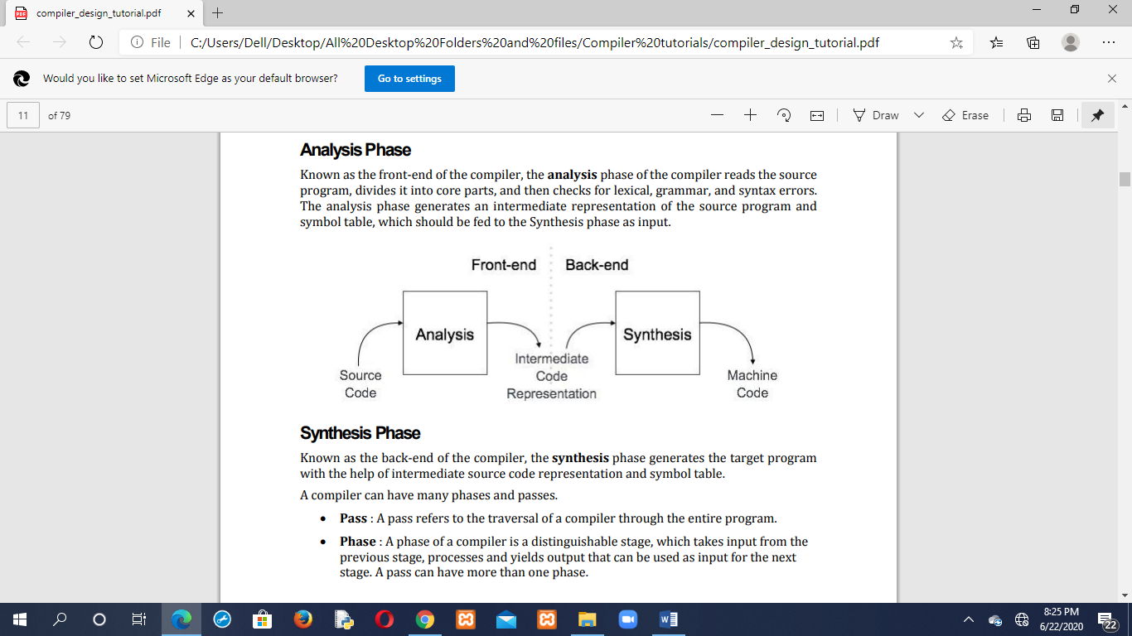 [2 marks for diagram]
- Analysis Phase: Known as the front-end of the compiler, the analysis phase of the compiler reads the source program, divides it into core parts, and then checks for lexical, grammar, and syntax errors. The analysis phase generates an intermediate representation of the source program and symbol table, which should be fed to the Synthesis phase as input. [2 marks].

- Synthesis Phase: Known as the back-end of the compiler, the synthesis phase generates the target program with the help of intermediate source code representation and symbol table. [2 marks].

- Types of Compilers

- Compilers that implement all the four processes of compilation in one module of compilation are called single pass compilers.
- Those that implement the phases in different modules are called multiple pass compilers. Multiple pass is best recommended for computers with low RAM capacity but they execute slower than the speed of CPU
- Compiler-Compilers: Compilers of today come in packages with editor, browser and real compiler (Integrated Development Environment, IDE). These are tools that can be used today to write a compiler. Compiler-compilers are generators which produce a compiler for a given language from a definition of the language. They are intended to save man-hours in compiler writing and speed up the production of compilers.
- Cross Compilers: these are translators which are used on one computer in order to produce object program that is used on a microcomputer. It is a compiler that runs on platform (A) and is capable of generating executable code for platform (B) is called a cross-compiler.
- Source-to-source Compiler: A compiler that takes the source code of one programming language and translates it into the source code of another programming language is called a source-to-source compiler. [2 marks each = 10 marks]

- Qualities of a good compiler are:
Good error diagnostics and reporting, Speed, Efficiency, Accuracy, Bug free, versatile, etc
[4 marks for any 4 points]
- The tasks that are involved in lexical analysis are:
(i) Breaking the source program into its basic elements called tokens
(ii) Producing tables for the basic elements
(iii) Presenting the source program in a more manageable (internal) form [3 marks]

(e) Important tasks performed by the parser
- Helps to detect all types of Syntax errors
- Checks that the input string is well-formed, and if not, reject it.
- Find the position at which error has occurred
- Clear & accurate description of the error.
- Recovery from an error to continue and find further errors in the code.
- Should not affect compilation of "correct" programs.
- The parse must reject invalid texts by reporting syntax errors [7 marks]

Question 2:
(a) Discuss the reasons for including Error Handling routines in Compiler design and construction [6 marks]
(b) The use of an undeclared identifier in a program is an error. The error could have arisen in several ways. Discuss. [3 marks]
(c) Explain the following levels of error in compiler construction: Notes, Comments, Warnings, Errors, Fatal errors and Deadly Errors [3 marks]
(d) What are the wish list of a compiler error handler? [3 marks]
Solution:
(a) Reasons for including Error Handling routines in Compiler design and construction
Error handling is concerned with failures due to many causes: Errors in the compiler or its environment (hardware, operating system), design errors in the program being compiled, an incomplete understanding of the source language by the compiler, transcription errors, incorrect data, etc.
The tasks of the error handling routine or process of a compiler are to detect each error, report it to the user and possibly make some repairs to allow processing to continue. The cause of the errors cannot be determined in any of the phases of compilation.
The purpose of the error handling process is to aid the programmer by highlighting inconsistencies. It has a low frequency in comparison with the other compiler tasks and hence the time required to complete it is largely irrelevant; but it cannot be regarded as an ‘add-on’ feature of a compiler. Proper design and implementation of an error handler however, depends strongly upon complete understanding of the compilation process. [6 marks]
(b) For an undeclared identifier, the error could have arisen in several ways such as:
- The identifier was misspelt on this use
- The declaration was misspelt or omitted
- The syntactic tree structure has been corrupted causing this use to fall outside the scope of the declaration. [3 marks]
(c) Levels of error in compiler construction
Levels 1 – 3 are reports of anomalies.
- Notes refer to non-standard constructs and are only important for programs that will be transported to other implementations.
- Comments criticize programming styles
- Warnings refer to possible errors
The remaining levels 4, 5 and 6 are reports of actual errors or violations of limits.
- Errors at level 4 can be repaired
- Fatal errors suppress production of an executable program (but the compiler may recover from them).
- Deadly errors cause compilation to terminate abruptly. [½ mark each = 3 marks]
(d) Wish list of a compiler error handler:
- Report the presence of errors clearly and accurately
- Recover from each error quickly enough to detect subsequent errors
- Add minimal overhead to the processing of correct programs [3 marks]
Question 3:
(a) The aspect of code generation in compiler construction is actually an arduous task. Why? [3 marks]
(b) The code generator should take some factors into consideration in order to generate the target code. Discuss any three of these factors [8 marks]
(c) Explain the alternatives available to a compiler designer to generate outputs after the quadruples, triples or the postfix forms of the source language have been generated [4 marks]
Solution:
(a) The aspect of code generation in compiler construction is actually an arduous task because:
It requires one to have a full knowledge of the operating system to be used and also to have full knowledge of the typical machine processor to be used, whether intel 80x86 series or Pentium. A code generator is expected to have an understanding of the target machine’s runtime environment and its instruction set. [3 marks]
(b) Factors to consideration in order to generate the target code:
- Target language: The code generator has to be aware of the nature of the target language for which the code is to be transformed. That language may facilitate some machine-specific instructions to help the compiler generate the code in a more convenient way. The target machine can have either CISC or RISC processor architecture.
- IR Type: Intermediate Representation has various forms. It can be in Abstract Syntax Tree (AST) structure, Reverse Polish Notation, or 3-address code.
- Selection of instruction: The code generator takes Intermediate Representation as input and converts (maps) it into target machine’s instruction set. One representation can have many ways (instructions) to convert it, so it becomes the responsibility of the code generator to choose the appropriate instructions wisely.
- Register allocation: A program has a number of values to be maintained during the execution. The target machine’s architecture may not allow all of the values to be kept in the CPU memory or registers. Code generator decides what values to keep in the registers. Also, it decides the registers to be used to keep these values.
- Ordering of instructions: At last, the code generator decides the order in which the instruction will be executed. It creates schedules for instructions to execute them.
[8 marks for any 4 points]
(c) There are actually four alternatives available to us to generate our output, which is the object code after we have generated the quadruples, triples or the postfix forms of the source language:
- We can generate an absolute machine language if we know the anatomy or architecture of the machine system, i.e. the registers.
- We can also generate a Re-locatable machine language but this entails having a link loader, which is another overhead, to assist in writing sub-programs individually and then link them together.
- We can also generate an assembly language, in which case, an assembler is needed.
- We can also generate another programming language. For example, taking BASIC or Java source lines to generate PASCAL or C language codes. There are existing code generator software that can take any source program and generate the codes needed by the machine. [4 marks]
Question 4:
(a) What is Optimization in Compiler Construction? [3 marks]
(b) A code optimizing process must follow three rules. What are they? [3 marks]
(c) Explain with relative examples, the differences between Machine Dependent and Machine Independent Optimization techniques in Compiler Construction [6 marks]
(d) What is an “Unreachable Code”? How is it handled in Code Optimization? [3 marks]

Solution
(a) Optimization is a program transformation technique, which tries to improve the code by making it consume less resources (i.e. CPU, Memory) and deliver high speed. In optimization, high-level general programming constructs are replaced by very efficient low-level programming codes. [3 marks]
(b) A code optimizing process must follow three rules:
- The output code must not, in any way, change the meaning of the program.
- Optimization should increase the speed of the program and if possible, the program should demand less number of resources.
- Optimization should itself be fast and should not delay the overall compiling process. [3 marks]
(c) (i) Machine-independent Optimization
In this optimization, the compiler takes in the intermediate code and transforms a part of the code that does not involve any CPU registers and/or absolute memory locations. For example:

do
{
x = 10;
value = value + x;
} while(value<100);

This code involves repeated assignment of the identifier x, which if we put this way:
x = 10;
do
{
value = value + x;
} while(value<100);
should not only save the CPU cycles, but can be used on any processor. [3 marks]

(ii) Machine-dependent Optimization
- Machine-dependent optimization is done after the target code has been generated and when the code is transformed according to the target machine architecture.
- It involves CPU registers and may have absolute memory references rather than relative references.
- Machine-dependent optimizers put efforts to take maximum advantage of memory hierarchy. [3 marks]

(d) Concept of Unreachable Code in Code Optimization
Unreachable code is a part of the program code that is never accessed because of programming constructs. Programmers may have accidently written a piece of code that can never be reached.
Example:
void add_ten(int x)
{
return x + 10;
printf(“value of x is %d”, x);
}

In this code segment, the printf statement will never be executed as the program control returns back before it can execute, hence printf can be removed. [3 marks]

